Domaca naloga 3

aws ec2 run-instances `
--image-id ami-02daa6fa3fe5f3161 `
--instance-type t3.small `
--key-name almaMaterDebianMoba `
--subnet-id subnet-0ed981e6f1cfa57c8 `
--security-group-ids sg-03425961a74cad30c `
--associate-public-ip-address `
--count 1 `
--tag-specifications "ResourceType=instance,Tags=[{Key=Name,Value=almaEC2-1}]" `
--user-data "#!/bin/bash
apt update -y
apt upgrade -y
apt install -y apache2
systemctl enable apache2
systemctl start apache2" `
--query "Instances[*].[InstanceId,PrivateIpAddress,PublicIpAddress,State.Name]" `
--output table

Ukazi:
#!/bin/bash
apt update -y
apt upgrade -y
apt install apache2 -y
systemctl enable apache2
systemctl start apache2
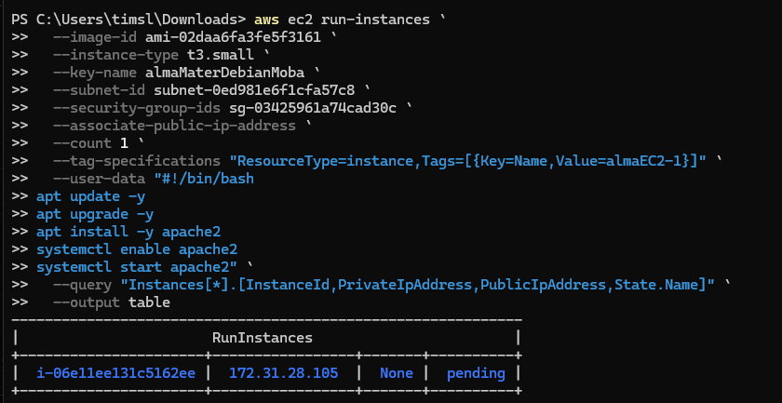

GIT
